**Banking Dashboard: Risk Analytics Using Power BI**

**🔍 Problem Statement**

To develop a strong understanding of **risk analytics** in the banking and financial services sector, and analyse how data-driven insights can help **minimize the risk of lending** to clients unlikely to repay.

**💡 Solution Overview**

Using **Power BI**, we developed interactive dashboards that help banks make informed decisions regarding loan approvals. By analysing customer profiles, financial behaviour, and account activities, the model identifies whether an applicant is **likely to repay the loan**. If the applicant's profile suggests high risk, the system flags it for potential denial thus reducing non-performing assets (NPAs).

**📁 Dataset Description**

The dataset includes comprehensive information on client banking activity and demographics. It comprises multiple **relational tables**:

* Banking Relationship
* Client-Banking
* Gender
* Investment Advisor
* Period

These tables are **interconnected via primary and foreign keys** to ensure seamless data integration.

**🧹 Data Cleaning & Feature Engineering**

* ✅ **Engagement Timeframe**: Created a new column in Client-Banking table to define the time period of client-bank relationship.

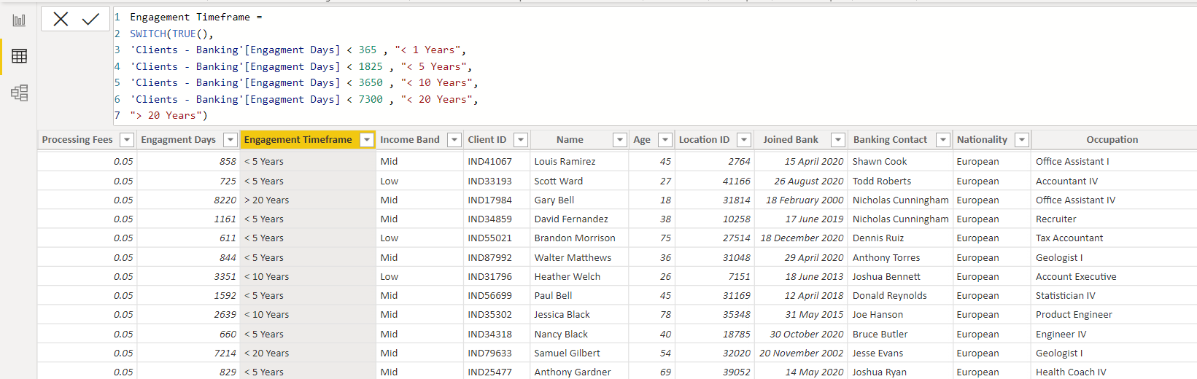

* ✅ **Engagement Days**: Calculated the number of days each client has been associated with the bank using:

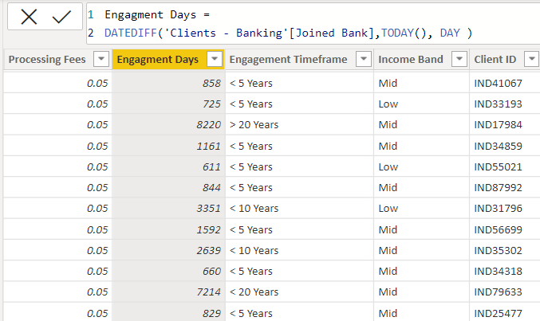

* Engagement Days = DATEDIFF('Client-Banking'[Joined Bank], TODAY(), DAY)

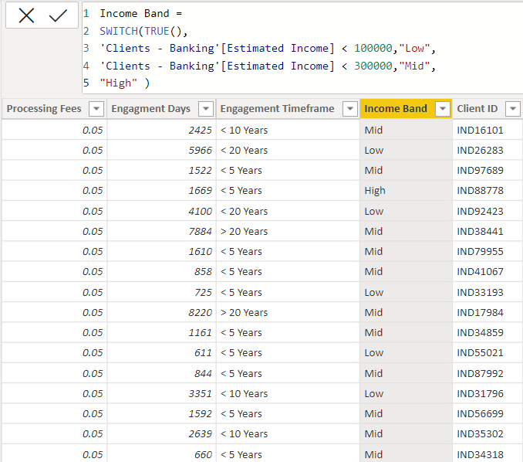

* ✅ **Income Band**: Binned Estimated Income into:
  + "Low" for income < ₹100,000
  + "Mid" for ₹100,000 ≤ income < ₹300,000
* ✅ **Processing Fees**: Assigned numeric values to the Fee Structure using:
* Processing Fees = SWITCH('Client-Banking'[Fee Structure], "High", 0.05, "Medium", 0.03, "Low", 0.01)

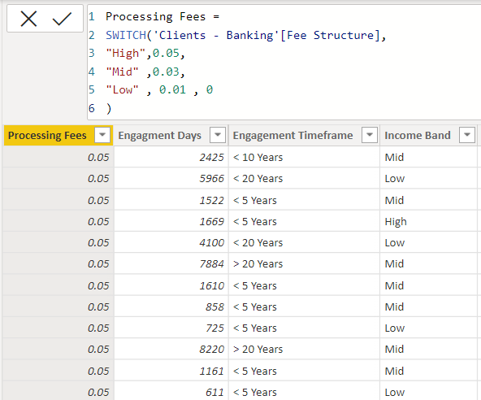

**📊 Calculated Measures**

**✅ Core Aggregations**

* **Total Clients**:
* Total Clients = DISTINCTCOUNT('Client-Banking'[Client ID])
* **Bank Loan**:
* Bank Loan = SUM('Client-Banking'[Bank Loans])
* **Business Lending**:
* Business Lending = SUM('Client-Banking'[Business Lending])
* **Credit Card Balance**:
* Credit Cards Balance = SUM('Client-Banking'[Credit Card Balance])
* **Bank Deposit**:
* Bank Deposit = SUM('Client-Banking'[Bank Deposits])

**✅ Composite Metrics**

* **Total Loan** = Bank Loan + Business Lending + Credit Card Balance
* Total Loan = [Bank Loan] + [Business Lending] + [Credit Cards Balance]
* **Total Deposit** = Bank Deposit + Savings Account + Checking Account + Foreign Currency Account
* Total Deposit = [Bank Deposit] + [Saving Account] + [Checking Account] + [Foreign Currency Account]
* **Total Fees** (based on loan value and processing fees):
* Total Fees = SUMX('Client-Banking', [Total Loan] * 'Client-Banking'[Processing Fees])

**📌 Key Performance Indicators (KPIs)**

* Total Clients
* Total Loan
* Total Deposit
* Total Fees
* Engagement Duration (in days)
* Credit Card Balances
* Income Distribution Bands

**📈 Dashboards & Visualizations**

We created the following dashboards:

* 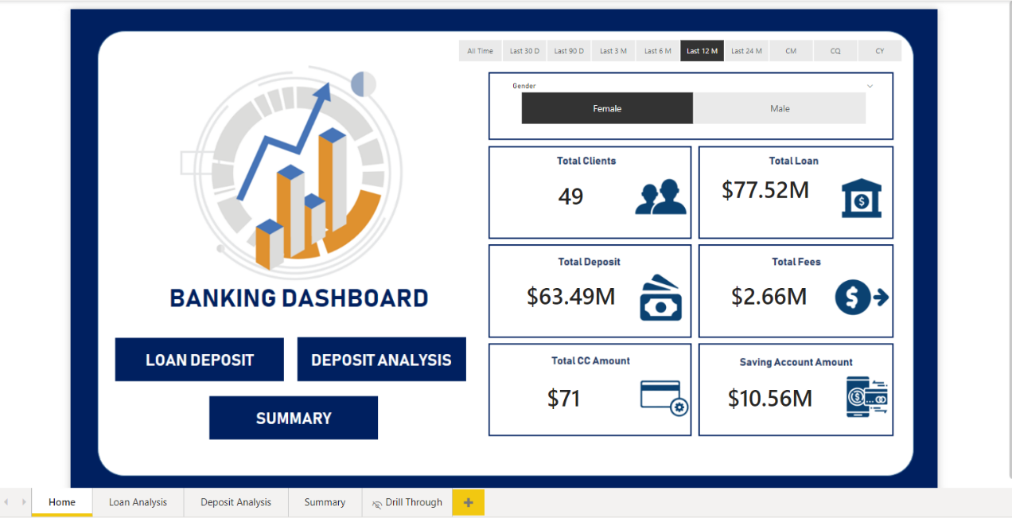**Home Overview**
* 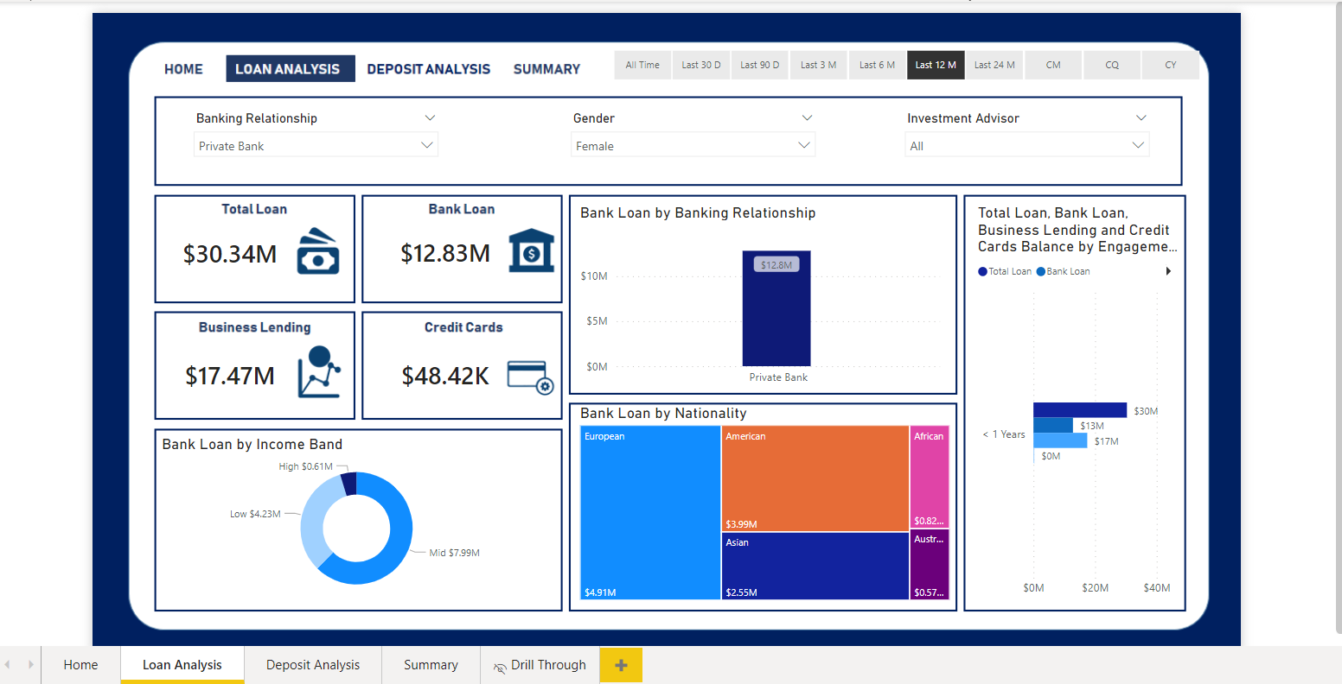**Loan Analysis** (by gender, advisor, nationality)

* 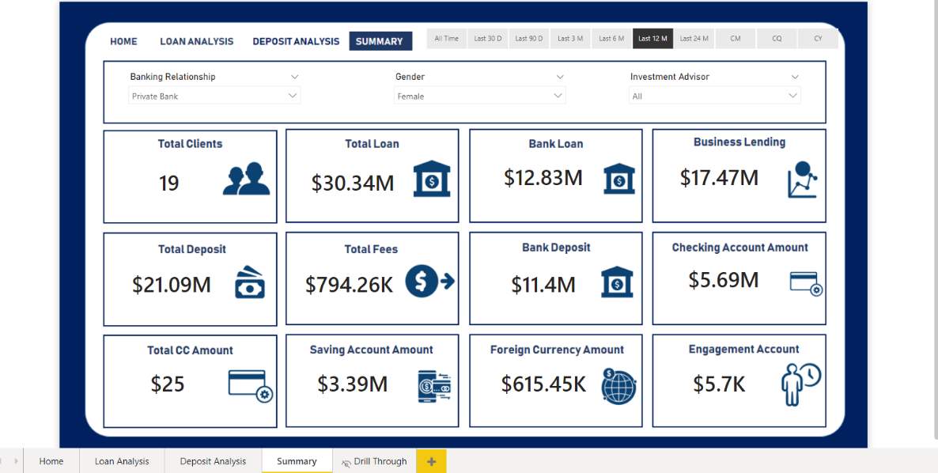**Deposit Analysis** (across different account types)

* 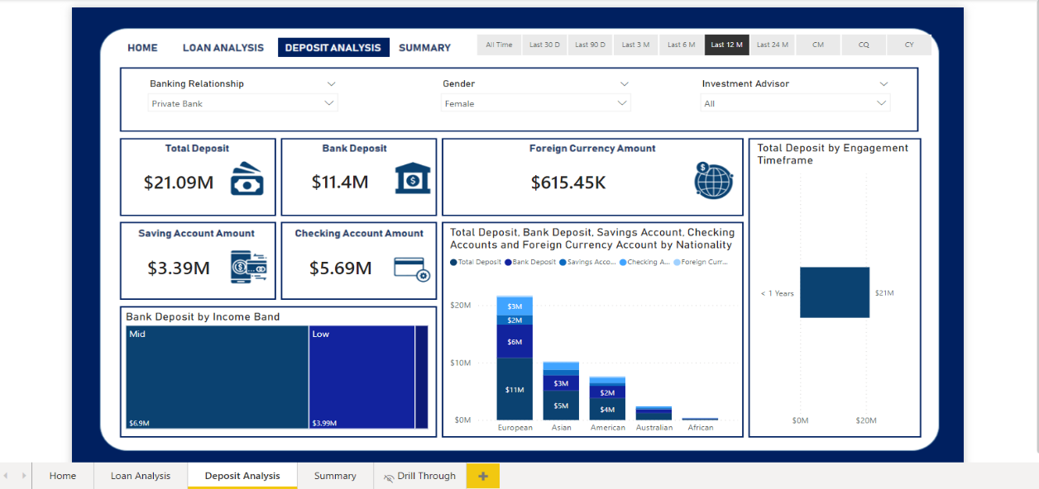**Summary Dashboard** (aggregate metrics, client segmentation, income bands)

**✅ Conclusion**

The Power BI dashboards offer powerful insights into **banking operations and customer behavior**. Banks can now:

* Assess **credit risk** more accurately
* Visualize which customer segments are **most profitable**
* Identify **high-risk borrowers**
* Understand which **nationalities or age groups** have the highest loan burdens
* Strategically **improve customer acquisition and retention**

**🔭 Future Scope**

* Enable **predictive risk scoring** by integrating machine learning models.
* Automate alerts for **high-risk clients** and **loan defaults**.
* Provide comparisons across **private vs. public banks** to identify strategies that attract more clients.
* Expand income band analysis to include **client behavior trends**.